**Neuro-Informatics: Integrating Deep Learning for Brain Image Analysis in Neurological Disorders**

## A Project Work Synopsis

*Submitted in the partial fulfilment for the award of the degree of*

## BACHELOR OF ENGINEERING IN

**ARTIFICIAL INTELLIGENCE & MACHINE LEARNING**

Submitted by:

RAGHAV BHATIA- 20BCS6371 ISHAL WALIA -20BCS6414 HARDIK SHARMA-20BCS6355

## Under the Supervision of : Priyanka Kaushik



**CHANDIGARH UNIVERSITY, GHARUAN, MOHALI - 140413, PUNJAB**

# Table of Contents

## INTRODUCTION*

* 1. Problem Definition 3
  2. Project Overview/Specifications* (page-1 and 3) 4
  3. Hardware Specification 6
  4. Software Specification 6

1. LITERATURE SURVEY
   1. Existing System 7
   2. Proposed System 7
2. PROBLEM FORMULATION 8
3. RESEARCH OBJECTIVES 8
4. METHODOLOGY 9
5. CONCLUSION 10
6. REFERENCES 10

**INTRODUCTION**

## PROBLEM DEFINITION:

The problem definition for the project "Neuro-Informatics: Integrating Deep Learning for Brain Image Analysis in Neurological Disorders" involves addressing the challenges associated with accurate and timely diagnosis, prognosis, and treatment planning for various neurological disorders using brain imaging data. Specifically, the project aims to develop and implement deep learning techniques to enhance the analysis of brain images obtained from modalities such as MRI, fMRI, CT, and PET scans. This includes tasks such as precise segmentation of brain structures and lesions, automatic detection and classification of neurological abnormalities, prediction of disease progression, and personalized treatment recommendation based on individual patient characteristics. The ultimate goal is to improve clinical decision-making, patient outcomes, and our understanding of the underlying mechanisms of neurological disorders through advanced computational methods applied to brain imaging data.

Neurological disorders encompass a wide range of conditions affecting the brain and nervous system, including but not limited to Alzheimer's disease, Parkinson's disease, multiple sclerosis, brain tumors, and stroke. Accurate diagnosis and effective management of these disorders are critical for patient care, yet they often pose significant challenges due to their heterogeneous nature and complex underlying mechanisms. Brain imaging plays a crucial role in the assessment and diagnosis of neurological disorders, providing valuable insights into structural and functional abnormalities. However, the interpretation of brain imaging data is often labor-intensive, subjective, and prone to inter-observer variability. Manual analysis methods are time-consuming, and there is a growing need for automated and objective approaches to assist clinicians in interpreting brain images more efficiently and accurately. Deep learning, a subset of artificial intelligence, has emerged as a powerful tool for medical image analysis, offering the potential to automate various tasks such as image segmentation, feature extraction, and disease classification. By leveraging deep learning techniques, this project seeks to address these challenges by developing robust and scalable algorithms

Keywords— Real time tracking, accident detection, reporting, traffic, safety, potholes, security and vehicle accident.

## PROJECT OVERVIEW/SPECIFICATION:

The project aims to leverage neuroinformatics principles to integrate deep learning techniques for analyzing brain images in the context of neurological disorders. It involves collecting and preprocessing diverse brain imaging datasets, including MRI, fMRI, CT, and PET scans, along with corresponding clinical data. Deep learning models will be developed and trained to perform tasks such as image segmentation, classification, and prognosis prediction. Model performance will be rigorously evaluated and validated using standard metrics, with a focus on clinical relevance and interpretability. Ethical considerations regarding patient privacy and data security will be addressed throughout the project, and efforts will be made to disseminate findings to the scientific community and facilitate technology transfer for real-world applications. By addressing these objectives, the project aims to advance the field of neuroinformatics and contribute to improved diagnosis, prognosis, and treatment of neurological disorders through the integration of deep learning for brain image analysis.

Specification of Project

The project addresses a critical need in healthcare by harnessing the power of neuroinformatics and deep learning to improve the diagnosis, treatment, and management of neurological disorders. Neurological disorders pose significant challenges due to their complex nature and heterogeneous manifestations, making accurate diagnosis and prognosis difficult. By integrating deep learning algorithms with brain image analysis, the project aims to enhance the precision and efficiency of disease detection, classification, and monitoring. This has the potential to significantly impact patient outcomes by enabling earlier interventions, personalized treatment plans, and better understanding of disease progression. Moreover, advancements in this field can contribute to the development of novel therapies and interventions tailored to individual patient profiles, ultimately improving the quality of life for those affected by neurological disorders. Overall, the integration of deep learning into neuroinformatics for brain image analysis holds great promise for advancing our understanding of neurological disorders, improving diagnostic accuracy, and ultimately guiding the development of more effective treatments. Neurological disorders encompass a wide range of conditions affecting the brain and nervous system, including but not limited to Alzheimer's disease, Parkinson's disease, multiple sclerosis, brain tumors, and stroke. Accurate diagnosis and effective management of these disorders are critical for patient care, yet they often pose significant challenges due to their heterogeneous nature and complex underlying mechanisms. Brain imaging plays a crucial role in the assessment and diagnosis of neurological disorders, providing valuable insights into structural and functional abnormalities.

## Process flow diagram

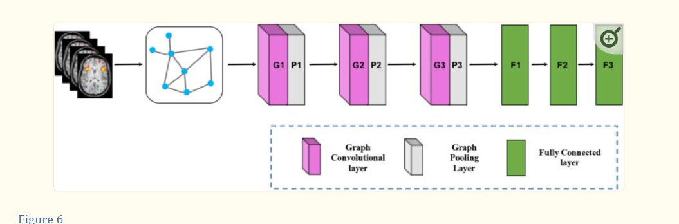

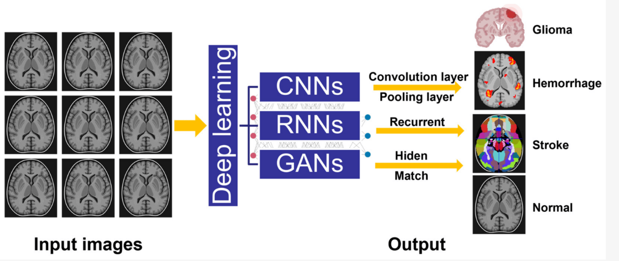

## HARDWARE SPECIFICATION:

* + 1. Windows operating system. 2)Python IDE

## SOFTWARE SPECIFICATION:

**Here the software used:**

Python IDE

1. Different libraries of python.
2. ANACONDA

# LITERATURE SERVEY

* Overview of Neuroinformatics and Deep Learning in Neuroscience:

Review foundational concepts and methodologies in neuroinformatics, including data acquisition, preprocessing, and analysis techniques.

* Brain Imaging Modalities and Neurological Disorders:

Survey the different brain imaging modalities used in neurological disorders, such as MRI, CT, PET, and fMRI, and their respective strengths and limitations.

* Deep Learning Techniques for Brain Image Analysis:

Investigate state-of-the-art deep learning architectures and methodologies for brain image analysis, including convolutional neural networks (CNNs), recurrent neural networks (RNNs), and generative adversarial networks (GANs).

* Clinical Applications and Case Studies:

Review studies demonstrating the clinical utility of deep learning-based approaches in neurological disorders, including diagnosis, prognosis, treatment planning, and monitoring.

## PROBLEM FORMULATION

Neurological disorders present significant challenges in diagnosis, treatment, and management, often complicated by the intricate nature of the brain's structure and function. Conventional methods for analyzing brain images, such as MRI, CT, PET, and fMRI scans, are labor-intensive, subjective, and prone to variability, hindering accurate diagnosis and effective treatment planning. There is a critical need for automated and objective approaches to analyze brain images, leveraging the power of deep learning and neuroinformatics to improve diagnostic accuracy, prognostic assessment, and personalized treatment strategies for neurological disorders. Therefore, the project aims to develop advanced deep learning models and integrate them into neuroinformatics workflows to automate brain image analysis, enhance clinical decision-making, and ultimately improve patient outcomes in neurological disorders.

## OBJECTIVES

The primary objective of the project is to develop and integrate deep learning techniques into neuroinformatics workflows for more efficient and accurate analysis of brain images in neurological disorders. Specifically, the project aims to address the following objectives:

* Automate the segmentation of brain structures and lesions from various imaging modalities.
* Develop deep learning models for disease classification, prognosis prediction, and treatment planning based on brain imaging features.
* Enhance the interpretability and clinical relevance of deep learning models to facilitate their integration into clinical practice.
* Address ethical and regulatory considerations related to patient privacy, data security, and algorithmic biases.

# METHODOLOGY

* Data Collection and Preprocessing:

Gather diverse brain imaging datasets comprising MRI, fMRI, CT, and PET scans, along with associated clinical metadata such as patient demographics, symptoms, and diagnoses.

* Deep Learning Model Development:

Design and implement deep learning architectures tailored to the specific tasks of interest, such as image segmentation, classification, or regression.

Experiment with different network architectures (e.g., Convolutional Neural Networks, Recurrent Neural Networks) and optimization techniques to optimize model performance.

* Model Training and Optimization:

Split the dataset into training, validation, and test sets, ensuring proper stratification and data balance.

* Clinical Integration and Interpretability:

Integrate the validated models into clinical workflows, providing clinicians with user-friendly interfaces for automated image analysis and decision support.

Enhance model interpretability through visualization techniques (e.g., activation maps, saliency maps) to facilitate understanding of model predictions and foster trust among healthcare professionals.

* Ethical Considerations and Regulatory Compliance:

Ensure compliance with ethical standards regarding patient privacy, data security, and informed consent throughout the project lifecycle.

* Dissemination and Knowledge Transfer:

Present the findings of the project through research publications in peer-reviewed journals, conference presentations, and workshops.

A. Limitation of Existing System

* Manual and Labor-Intensive Processes: Current methods often rely on manual segmentation and analysis of brain images, which are time-consuming, subjective, and prone to inter-observer variability. This limits scalability and efficiency in large-scale clinical studies and real-world applications.
* Limited Automation and Objectivity: Many existing systems lack automation and objectivity in image analysis, leading to inconsistencies and errors in disease detection, classification, and quantification. This can impede accurate diagnosis and treatment planning, particularly in complex neurological disorders with subtle imaging features.
* Single-Modality Analysis: Most systems focus on analyzing brain images from a single modality (e.g., MRI, CT), overlooking the potential benefits of multi-modal fusion for comprehensive disease characterization. Integrating information from multiple modalities could provide a more holistic understanding of neurological disorders and improve diagnostic accuracy.

## CONCLUSION

By leveraging neuroinformatics principles and deep learning techniques, the project aims to address critical challenges in brain image analysis, including accurate diagnosis, prognosis, and treatment planning. Through the development of robust and scalable deep learning models, this project seeks to automate and enhance the analysis of diverse brain imaging modalities, paving the way for more objective, efficient, and personalized healthcare interventions. Furthermore, by integrating these models into clinical workflows and ensuring ethical and regulatory compliance, the project aims to facilitate the adoption of advanced computational methods in real-world clinical practice. Ultimately, the success of this project has the potential to improve patient outcomes, advance scientific understanding, and drive innovation in the field of neuroinformatics and neurological disorders research.

# REFERENCES

1. Pesapane F., Codari M., Sardanelli F. Artificial intelligence in medical imaging: Threat or opportunity? Radiologists again at the forefront of innovation in medicine. Eur. Radiol. Exp. 2018;2:35. doi: 10.1186/s41747-018-0061-6. [PMC free article] [PubMed] [CrossRef] [Google Scholar]

2. Bonacchi R., Filippi M., Rocca M.A. Role of artificial intelligence in MS clinical practice. Neuroimage Clin. 2022;35:103065. doi: 10.1016/j.nicl.2022.103065. [PMC free article] [PubMed] [CrossRef] [Google Scholar]

3. Diaz-Hurtado M., Martinez-Heras E., Solana E., Casas-Roma J., Llufriu S., Kanber B., Prados F. Recent advances in the longitudinal segmentation of multiple sclerosis lesions on magnetic resonance imaging: A review. Neuroradiology. 2022;64:2103–2117. doi: 10.1007/s00234-022-03019-3. [PubMed] [CrossRef] [Google Scholar]

4. Guan X., Yang G., Ye J., Yang W., Xu X., Jiang W., Lai X. 3D AGSE-VNet: An automatic brain tumor MRI data segmentation framework. BMC Med. Imaging. 2022;22:6. doi: 10.1186/s12880-021-00728-8. [PMC free article] [PubMed] [CrossRef] [Google Scholar]

5. Saba L., Biswas M., Kuppili V., Cuadrado Godia E., Suri H.S., Edla D.R., Omerzu T., Laird J.R., Khanna N.N., Mavrogeni S., et al. The present and future of deep learning in radiology. Eur. J. Radiol. 2019;114:14–24. doi: 10.1016/j.ejrad.2019.02.038. [PubMed] [CrossRef] [Google Scholar]

6. Chen R., Huang J., Song Y., Li B., Wang J., Wang H. Deep learning algorithms for brain disease detection with magnetic induction tomography. Med. Phys. 2021;48:745–759. doi: 10.1002/mp.14558. [PubMed] [CrossRef] [Google Scholar]